RFP for Northern Chautauqua County Intermunicipal Local Waterfront Revitalization Program

Deadlines
Published – January 6th, 2017
Deadline – February 3rd, 2017
Anticipated Award Date – February 23rd, 2017

Available at http://bit.ly/NCCLWRPPHASEII and on the NYS Contract Reporter #2029607

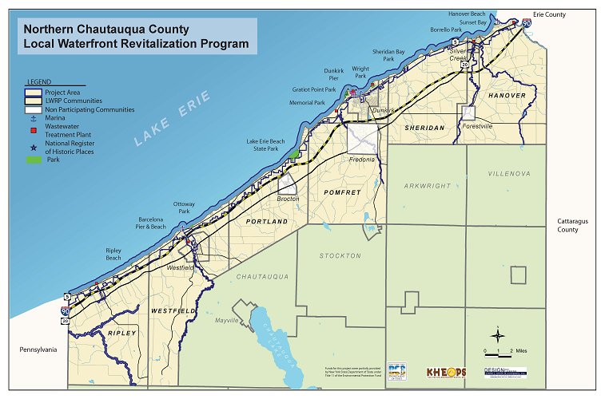
Summary
The County of Chautauqua is requesting proposals from qualified consultants to assist in the completion of Phase II of a Local Waterfront Revitalization Program (LWRP) for the ten municipalities located in Northern Chautauqua County (NCC), New York along Lake Erie. In 2015, under Phase I of the Northern Chautauqua County Local Waterfront Revitalization Program (NCC LWRP), the County prepared a Preliminary Draft LWRP. Phase II of the NCC LWRP will consist of completion of the LWRP process. The selected consultant will undertake completion of the Preliminary Draft LWRP by:
- Undertaking necessary revisions to the Preliminary Draft LWRP based on DOS and Waterfront Advisory Committee review,
- Completing full drafts of all amendments to existing laws or new local laws necessary to implement the LWRP for the ten communities within the boundary area,
- Completing resolutions for each municipal legislative body accepting the Draft LWRP as complete and ready for submission to DOS for review and initiation of the 60-Day review process,
- Preparing for and holding public information meeting(s) to solicit additional stakeholder and public input and present the Draft LWRP,
- Completing revisions agreed upon by DOS, Contractor, Consultant, and Municipalities necessitated by comments from State, Federal, and other local agencies following 60-Day Review,
- Determination of significance and compliance with the State Environmental Quality Review Act (SEQRA),
- Creating a schedule for LWRP adoption, and
- Complying with all provisions in the contract between the NYS DOS and County of Chautauqua, including the NYS DOS Minority and Women-owned Business Enterprises (MWBE) goals.
The traditional project components of an LWRP, which must be completed, are described in detail in Section 1.2 Scope of Work of the RFP. Although consultants must fulfill the traditional components of an LWRP, consultants are encouraged to be creative and to include additional elements or processes for completing an LWRP that would benefit the ten communities of Northern Chautauqua County. New York State MWBE goals apply to this project and consultants are encouraged to subcontract, form joint ventures and partnerships, and collaborate to assemble a consultant team that satisfies MWBE goals of 15% WBE and 15% MBE.

Inquires
Primary
Don McCord, Deputy Director of Chautauqua County Planning & Economic Development
716-661-8910
mccord@co.chautauqua.ny.us

Secondary
Pat Gooch, Senior Planner/LWRP Project Manager
716-661-8922
goochp@co.chautauqua.ny.us

